 

**Placement Empowerment Program**

***Cloud Computing and DevOps Centre***

**Use Cloud CLI Tools Install the CLI for your cloud provider (e.g., AWS CLI).** Use it to list resources, upload files to storage, and manage VMs.

Name: Mathimalar.P Department : ADS



**Introduction and Overview**

Cloud Command Line Interface (CLI) tools provide a powerful way to interact with cloud platforms such as AWS, Azure, and Google Cloud. These tools allow users to manage resources, automate tasks, and execute cloud operations efficiently without needing a graphical interface.

**Objective**

The goal of using Cloud CLI tools is to simplify cloud resource management by executing commands for tasks such as listing resources, uploading files, and managing virtual machines (VMs).

**Importance**

• Efficiency: Faster execution compared to GUI-based operations.

• Automation: Enables scripting and automation of repetitive cloud tasks.

• Flexibility: Allows remote cloud management from any terminal.

• Cost-Effective: Reduces operational overhead by enabling quick and precise resource control.

**Step-by-Step Overview**

**STEP 1**: Install the AWS CLI:

o For Windows:

▪ Download the installer from the AWS CLI official page.

Run the installer and follow the on-screen instructions.

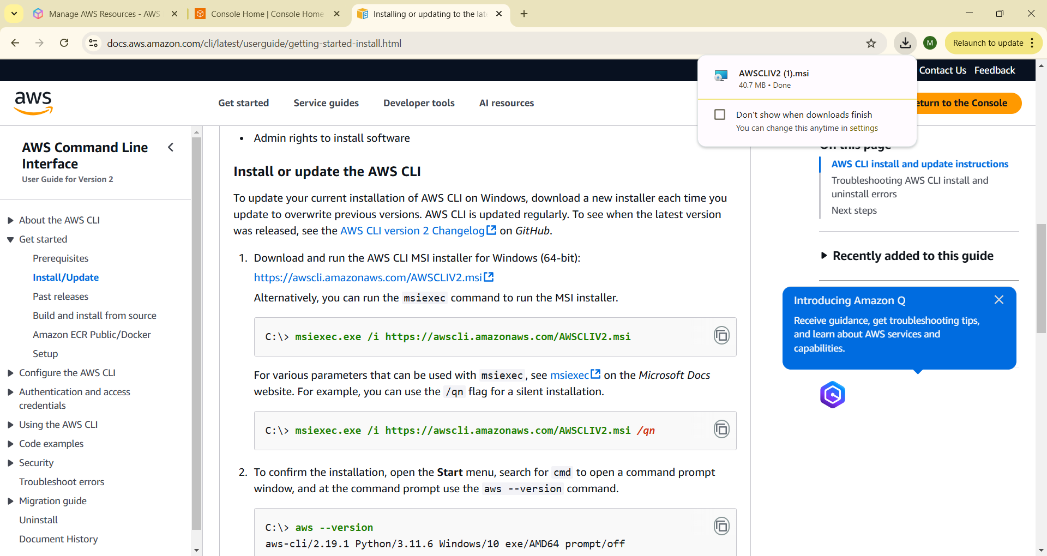

**STEP 2:**

Verify the Installation:

aws –version

Output should display the AWS CLI version installed.

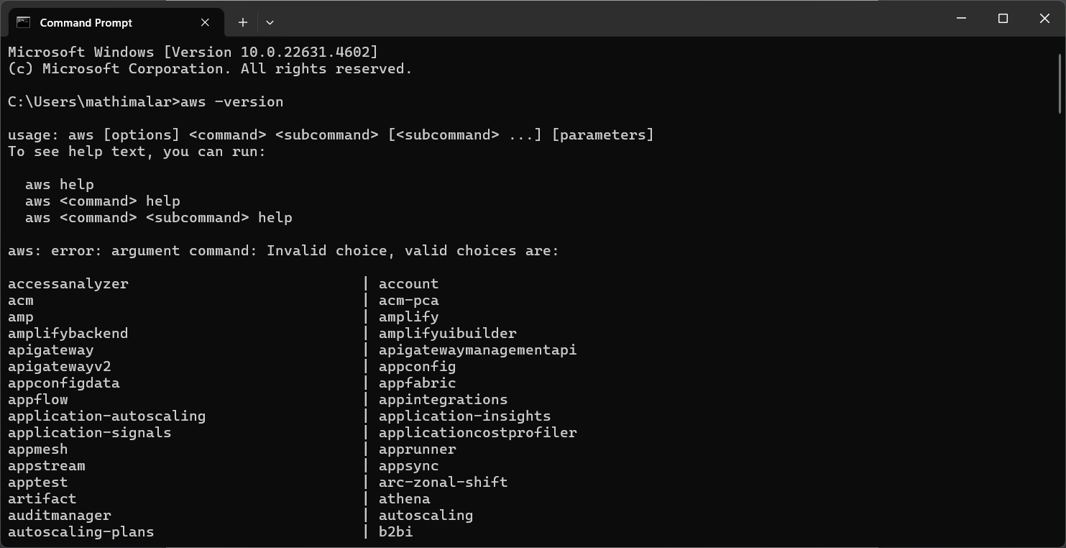

**STEP 3:**

Create an Access Key for AWS CLI:

● Sign in to the AWS Management Console.

● Go to the Security credentials tab.

● Under Access keys, click Create access key.

● Select Command Line Interface as Use case

● Download the .csv file containing your Access Key ID and Secret Access Key

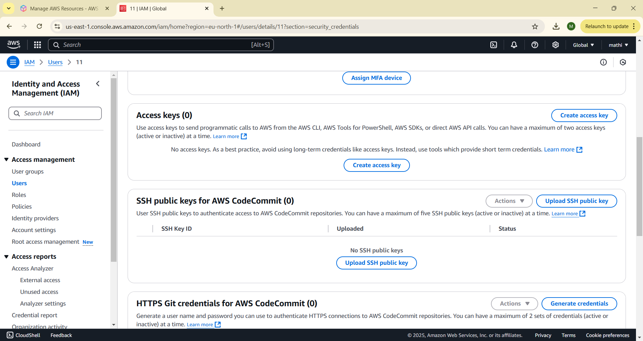

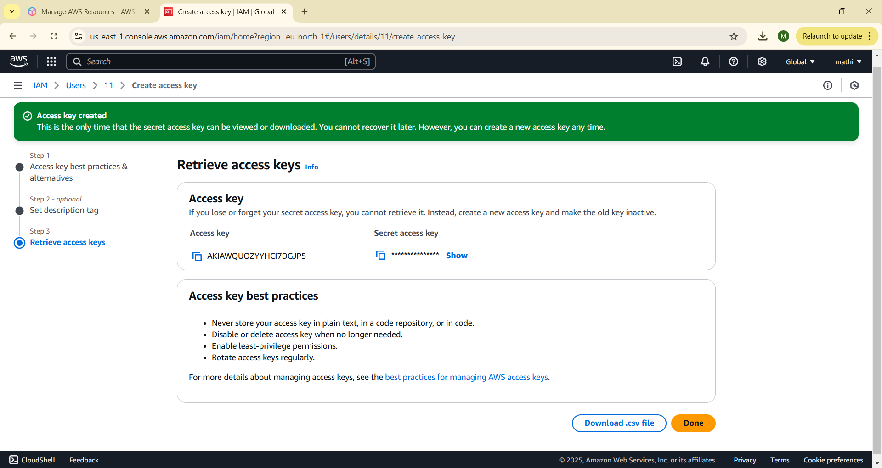

**STEP 4:**

Configure the AWS CLI:

aws configure

Provide the following details when prompted:

o AWS Access Key ID

o AWS Secret Access Key

o Default region name (e.g., us-east-1)

o Default output format (e.g., json)

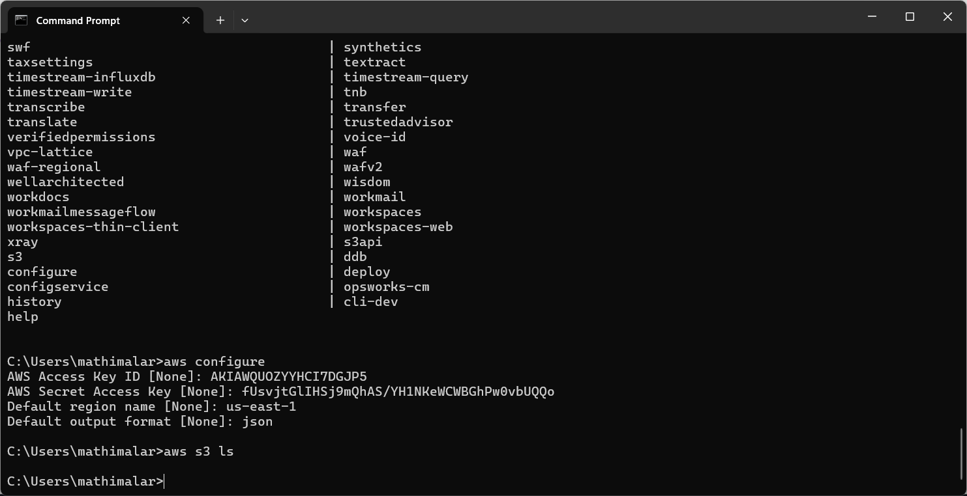

**STEP 5:**

List AWS Resources:

o List all S3 buckets:

aws s3 ls



**Outcome**

By mastering Cloud CLI tools, users can efficiently interact with their cloud infrastructure, automate workflows, and enhance productivity in cloud-based projects.